User Guide
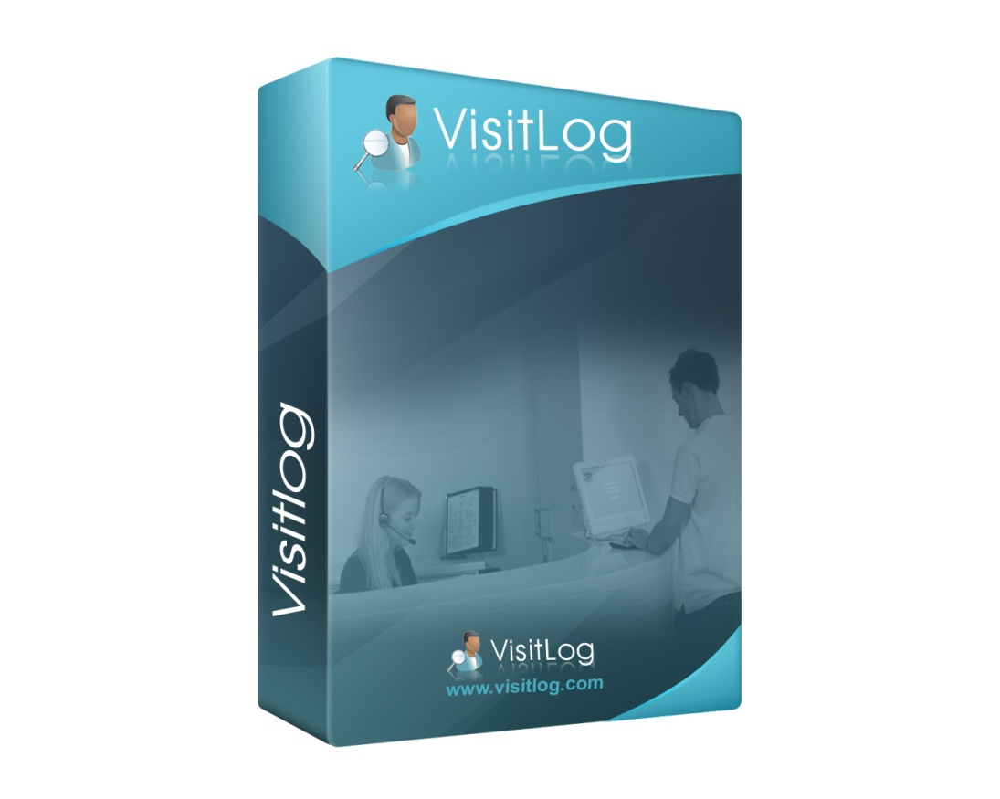

VisitLog 4.x

Content

1 Introduction 4
2 What is VisitLog 4
2.1 VisitLog is made up of two applications: 4
3 Before you start 4
4 Overview page 5
5 Administration 6
5.1 Local settings 6
5.1.1 Active Directory LDAP koppling 7
6 General settings 8
7 Visitor badge 9
8 Visitor screen 10
9 Message to host (SMS/Mail) 11
9.1 Mail 11
9.2 SMS 12
10 Visitor messaging 13
11 List of availible hosts 13
12 List of visitors 13
13 Userdefined fields (Extra fields at visitor kiosk) 14
13.1 Edit field visibility (At visitor kiosk) 15
14 Language for visitlog kiosk screen 16
15 Surveys 17
15.1 Create survey 17
15.2 Add survey values 18
15.3 Create questions to survey 19
15.4 Example: One question 20
15.5 Emergency list settings 21
16 Sign in visitor from Kiosk 22
17 Logg in visitor from Manager application 23
18 Prebook visitor 24
19 Check out visitor 25
19.1 Check out with barcode scanner 26
20 Search 27
21 Choose columns for lists 28
22 Statistics 29
23 Time report 30
23:1 Users and Roles …………………………………………………………………………………………………………………. 31
24 Presentation screen 34
25 Short Cut Commands 34

Introduction
This user guide aim to help both users and administrators. Installation process is not included in this document, you will find it at: http://support.riwsoftware.com.

What is VisitLog
Visitlog is a Visitor Management System to get control over visitors in an organization. VisitLog will fit in both small and big companies.

VisitLog is made up of two applications:
- Manager: This is receptions and configuration program.
- Kiosk: This is visitor entry application.

Before you start
There is some different way to configure VisitLog. Below you can find how it will fit your organization in best way.
- Photo: You can set up system with or without camera option.Camera option will take a picture of visitor at login moment. Picture will also be saved in database.
- Logo:Best option is to provide a preprinted badge with company logo. This can easy be made by sent us a mail with company logo.
- Limit visitor hosts: You can set up system to be able to receive any visitor to any host, even new not in system. Or you can limit visitors to just be able to visit hosts in system list.
- Check out:
  - You can set system to automatic check out all visitors at a preset time or at midnight.
  - You can let receptionist logout all visitors to keep full control at visitors all day.
- Checkout with barcode scanner: With this function its very easy to check out visitors. Either by them self or by reception personnel.
- Message to host: Its possible bo configure VisitLog to send message to host by either mail or SMS. You need a sms provider to do this. In Sweden we have ex of these:
  - http://www.smsteknik.se
  - http://www.pixiew.com

Overview page
At overview page you will find all functions in system. VisitLog will provide short cut commands for most important functions also.You will find at end of this document.

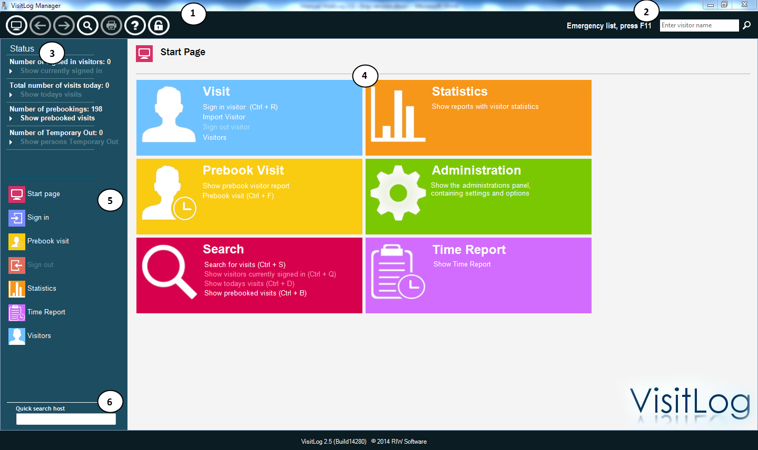
- Head menu: From left it is: Main page, Next and prev forms, Search, Print lists, Helpd, License function.
- Emergency list:By pressing F11 key (could be changed), emergency list is printed or mailed.
- Status list:Overview of ongoing activities. Count of visitors now, today and total.
- All functions: Is listed here for easy handling.
- Short cuts: To most used functions in system.
- Quick Search: To hosts in system. Easy to search and find information about hosts

Administration
In administration user can configure all functions in system. Here is a list of all functions.

Local settings

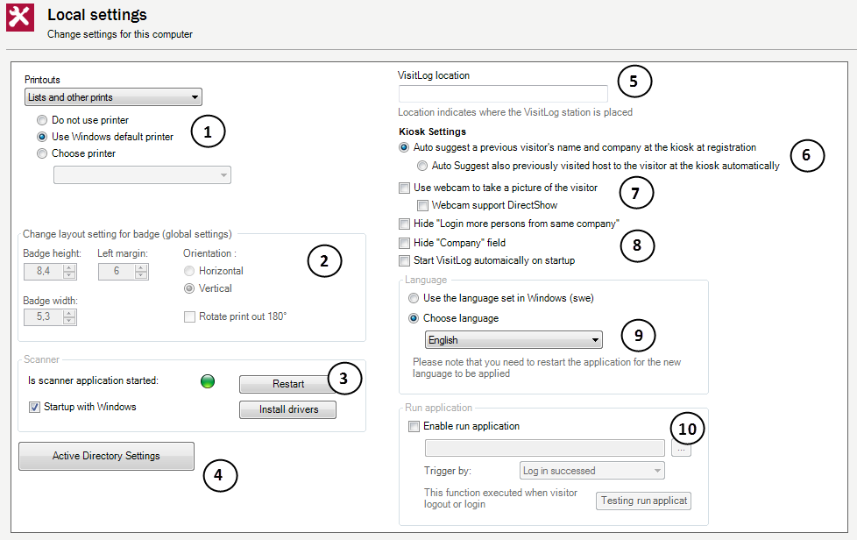
- Printer settings: Settings for print badge, parking badge and Wifi code and other lists as for example emergency list and reports.
- Badge size: Here is settings for visitor badge size in printer.
- Scanner function: This setting is for barcode scanner and driver function. If Start with Windows is checked it will allways start when computer start. Scanner is for check in or check out visitors with barcode at badge.
- Active Directory connection/LDAP: Connects to company user system and synch hosts to VisitLog system. Check more about AD connection below.
- Location: You can write location of kiosk/manager in this field. It can be used later in send message function to host, to tell where the visitor entered the building.
- Give suggestions:Sytem can be configured to give examples for visitor that he/she been there before. This will speed up registration process.
- Camera/Photo: This option will activate photo/camera option.
- Standard fields: This option will hide/show fields at visitor kiosk.
- Language: Set language to be used in manager application.
- Application run: Its possible to run an application at check in/check out. It could be ex: Open door function.

Active Directory LDAP koppling

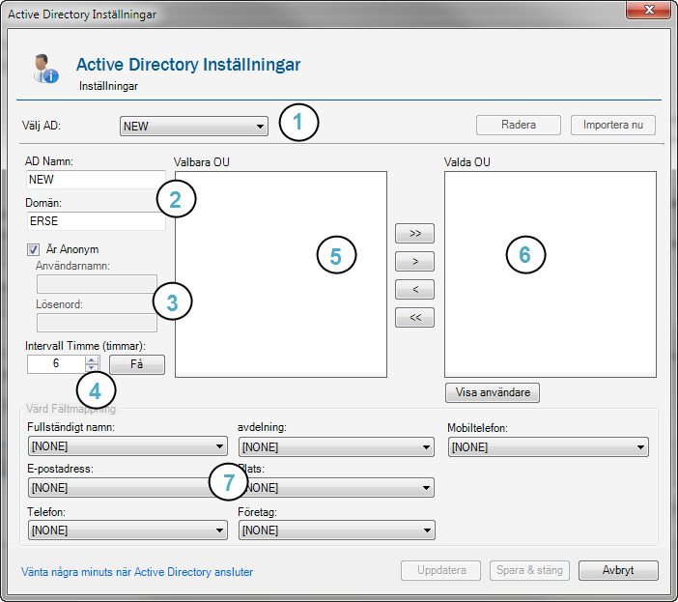
- New connection or existing will be selected here.
- Give a name and domain
- Give user and password if needed.
- Give an interval for synch process.
- Here is existing OU’s to select.
- Move OU’s to be selected to this side.

General settings

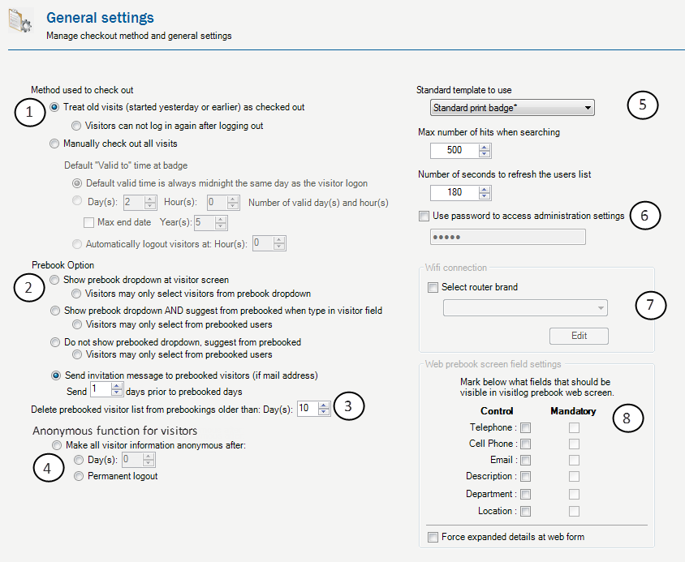
- Check out options:Visitlog can checkout visitors automatically or by user. Use top option to make it automatically and bottom option to make it manually.
- Prebooked visitors options: Option to make it possible to choose prebooked visitors and prefill fields at visitor kiosk. You will find different options here.
- Clear prebooked list: Possible to set system to clear prebooked list for bookings not activated.
- Anonymous: Possible to set visitor information to not readable after some time. All statstics is still in system.
- Standard badge: Give standard badge to system settings. List limitations: Give list limitation to system lists for performance.
- Update time: Time interval to update lists in system.Admin password: Possible to set password to admin panel.
- Wifi settings: Settings to connect and create wifi users in wireless network.
- Web prebooking page: Possible to set what visitor fields to be seen in the visitor web prebooking page.

Visitors badge

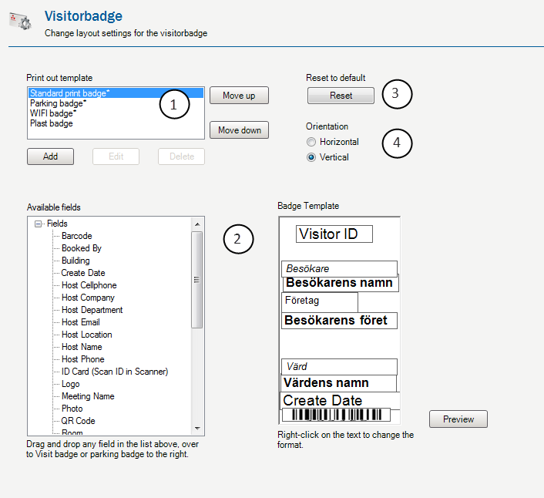
- Badges templates: Possible to create and design multiple templates for visitors. Templates with an “*” is standard templates in system.
- Badge design: Design the selected badge from template above. Drag fields from available fields to badge template to right.Right click for edit control fields at template.
- Reset: User can reset to standard layout/desgn.
- Orientaion: Set orientation for badge during design.

Test print badges to get the desired result.

Visitor screen

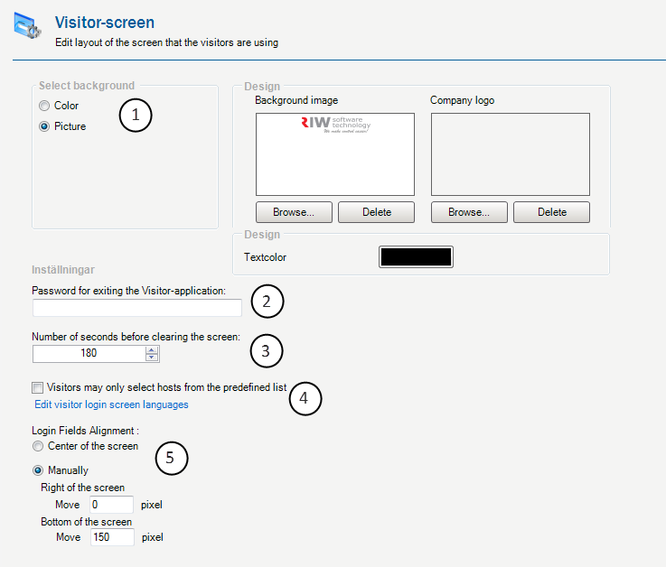
- Set picture or color at visitor kiosk screen.
- Password to close visitor kiosk application.
- Number of seconds for clear screen.
- Set visitors to only choose from existing hosts in system.
- Change location of fields in kiosk.

Message to host (SMS/Mail)
These settings is for sending mail or sms to host at visitor checkin.

Mail

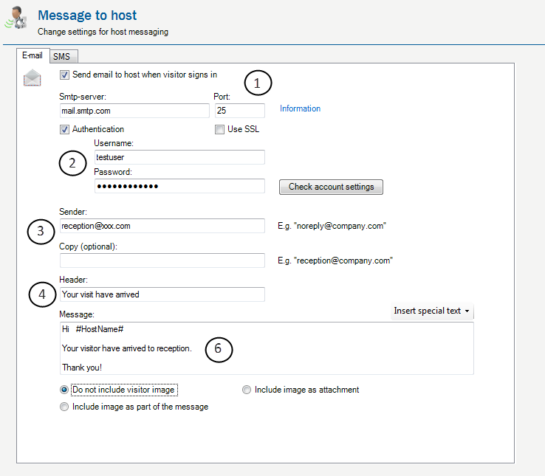
- Smtp server to send by
- Smtp server password if needed.
- Sender of mail.
- Titel for sent mail.
- Message can include special ”words” to replace when message is sent.

SMS

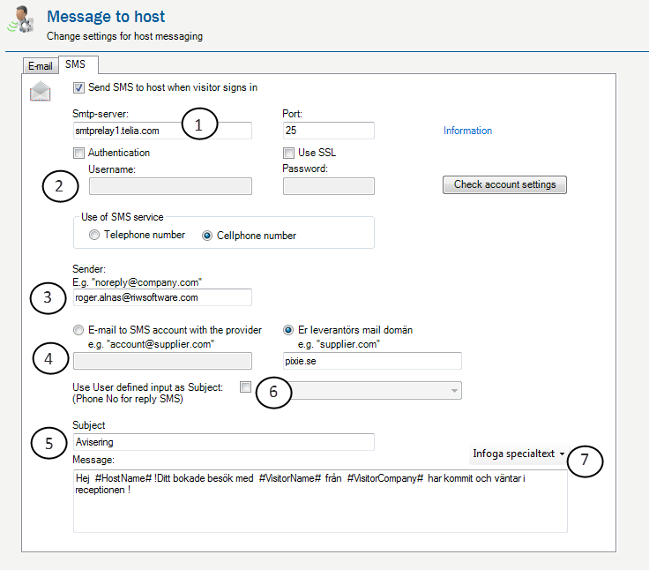
- Smtp server to send by
- Smtp server password if needed.
- Sender of mail.
- SMS provider should be entered here. Could be different format.
- Titel for sent mail. Message can include special ”words” to replace when message is sent.
- Send mobile number (if entered in kiosk screen). To be able to communication between visitor and host.
- Insert special characters in message.

Visitor messaging
This make prebook messages to be sent. For example: You are welcome to our company at 16:00 the 4 of july. Please read this prior to visit.
- Settings for messaging is same as Host messaging above.

List of availible hosts

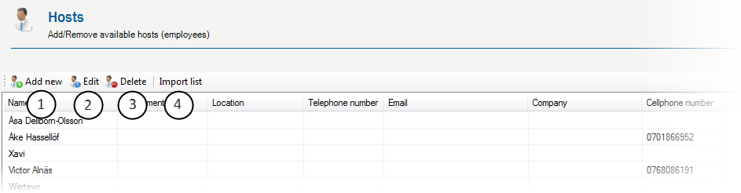
- Add hosts manually. (See Active Directory import above.
- Edit host.
- Remove hosts.
- Import host by excel or text file.

List of visitors
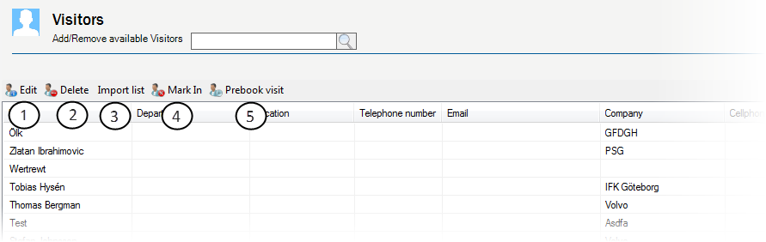
- Edit visitors manually.
- Remove host.
- Import host by excel or text file.
- Mark as check in
- Prebook a visitor in visitor list

Userdefined fields (Extra fields at visitor kiosk)

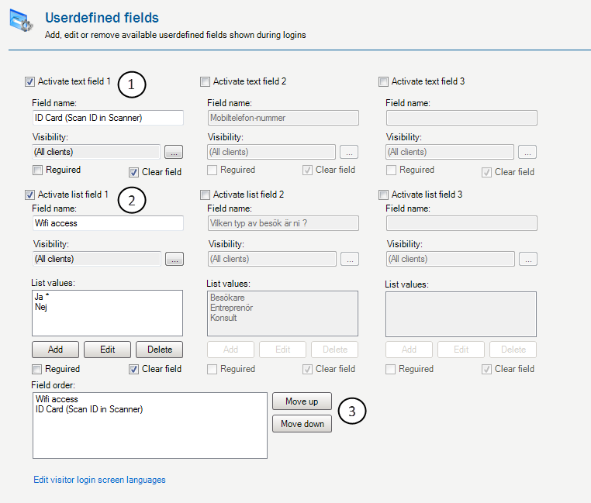
- Add field to kiosk. This is a simple text field. Field can be set to show at specific kiosks only.
- Add a list field. There is different options to each list value in drop down list.
- Order of filelds at Visitor kiosk.

Edit field visibility (At visitor kiosk)

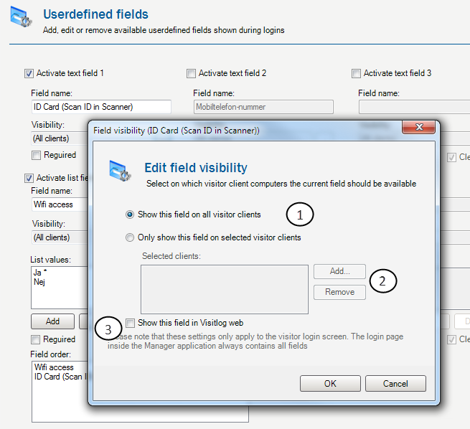
- Show at all kiosks or second option to show at specific kiosk terminals.
- Add computor name for actual computor to show field.
- This will tell visitlog prebook, webappllication to show field at web page.

Language for visitlog kiosk screen

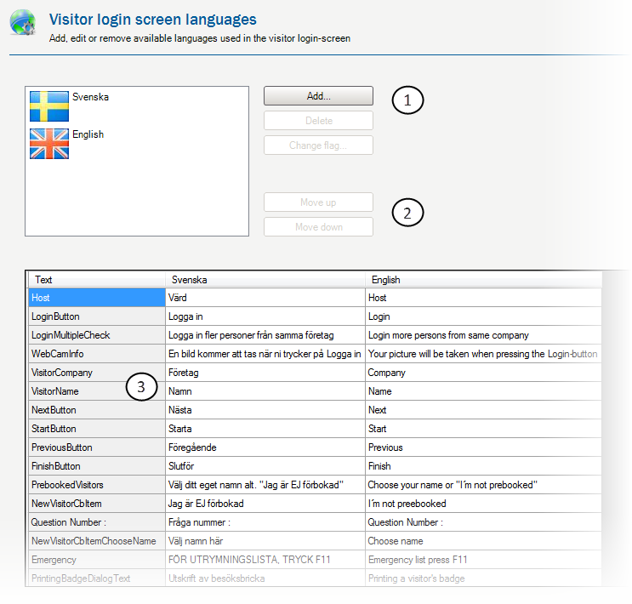
- Select flag to be visible at kiosk screen. Add new language.
- Select order to be show and what to be default language.
- Edit text to match language.

Surveys
Surveys can be created to pop up at kiosk screen and visitor answer questions. To activate survey you can to either as follows:
- Create a predefined list and give option to list value for start survey.
- Activate a survey for all that logon to visitlog.

Create survey
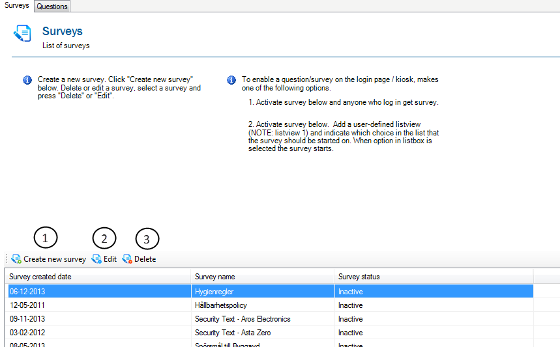
- Create new survey
- Edit existing survey
- Delte existing survey

Add survey values
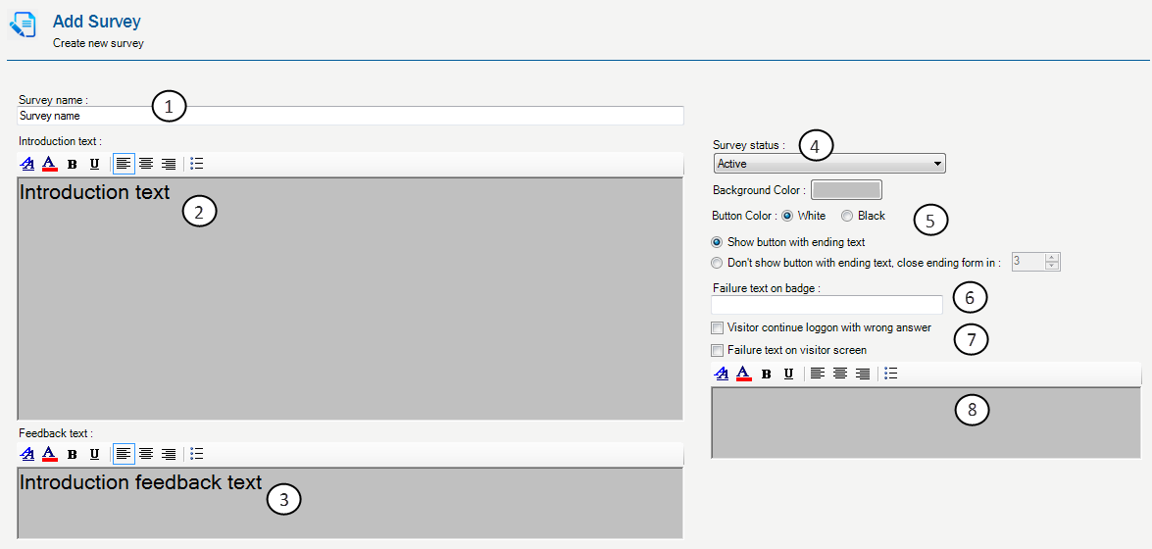
- Name of survey.
- First page introduction text. If needed use this, other case just use question forms, leave this blank.
- Ending text. Use if needed to give visitors a text after finish survey. Leave blank to not use.
- Status of this survey. One active at same time.
- Background color of survey. Possible to show ending button or make system close survey after x seconds.
- Wrong answer text to show at visitor badge. For example: Don’t enter operation building.
- User can be logged in even if answer is wrong.
- Message to be show after wrong answer at screen.

Create questions to survey
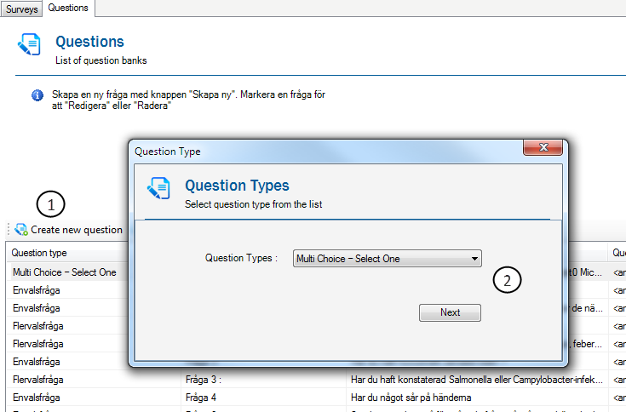
- Create new
- Type of question (Now only one option)

Example: One question
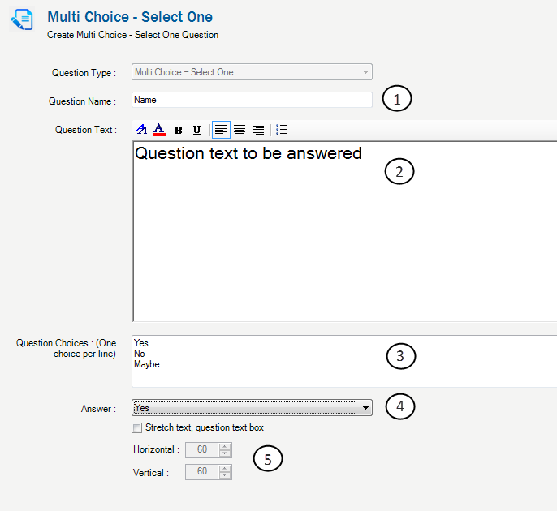
- Question name
- Give question to be answered.
- Give answer alternatives. It can be YES/NO or text.
- Give what value that is CORRECT answer.
- If needed use this to adapt area of question at screen.

Emergency list settings
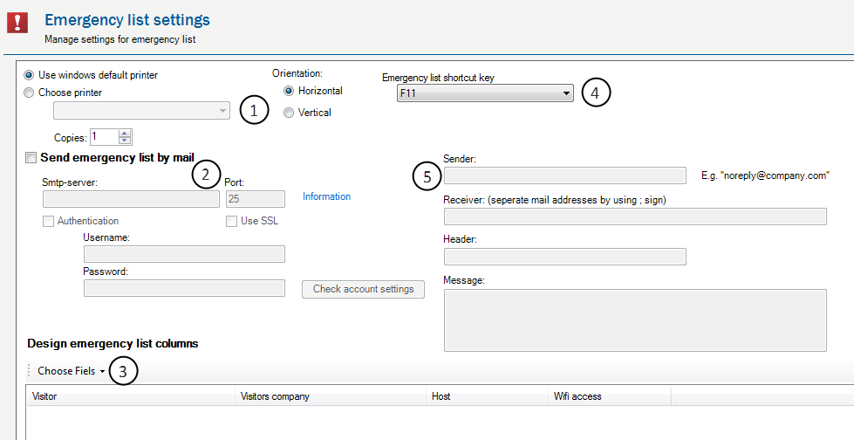
- Choose printer for emergency list.
- If list should be mailed, you have to give details here for SMTP server. Ask network administrator if any problem.
- Select columns to be used at emergency list.
- Set what function key to be used for activate emergency list. This will visible at both Manager application and Kiosk application.
- Give details for sending mail and what message should be.

Sign in visitor from Kiosk
There is three diffent ways to sign in visitors. 1. In kiosk by visitor, 2. By reception in Manager appliction, 3. By prebooking function.
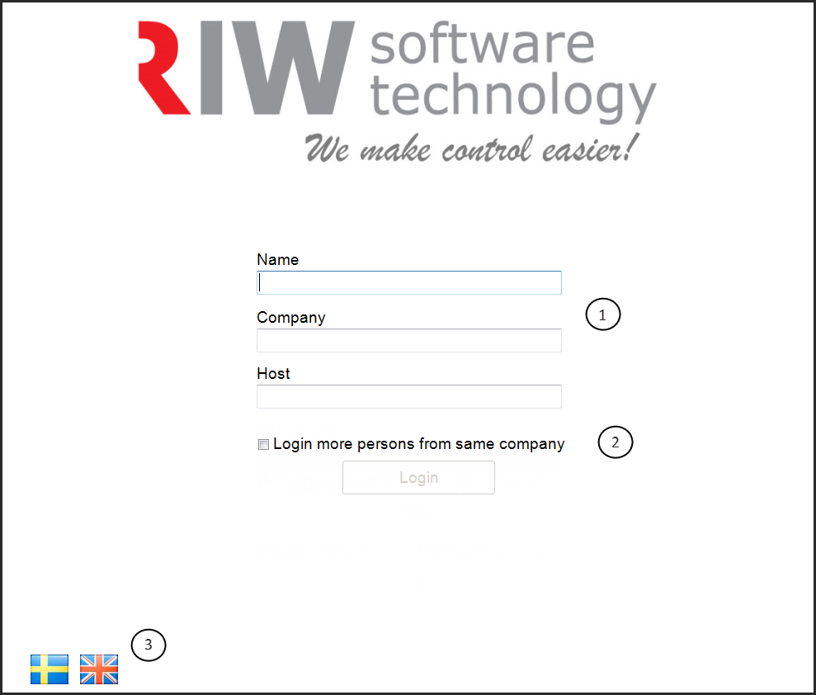
- Visitor give name, company and host. (Its possible to hide company field).
- If many users visit same Host, it’s possible to save Company and Host name at screen by check the checkbox.
- There is two langugage default in system. But users can very easy add as many as they like.

Logg in visitor from Manager application
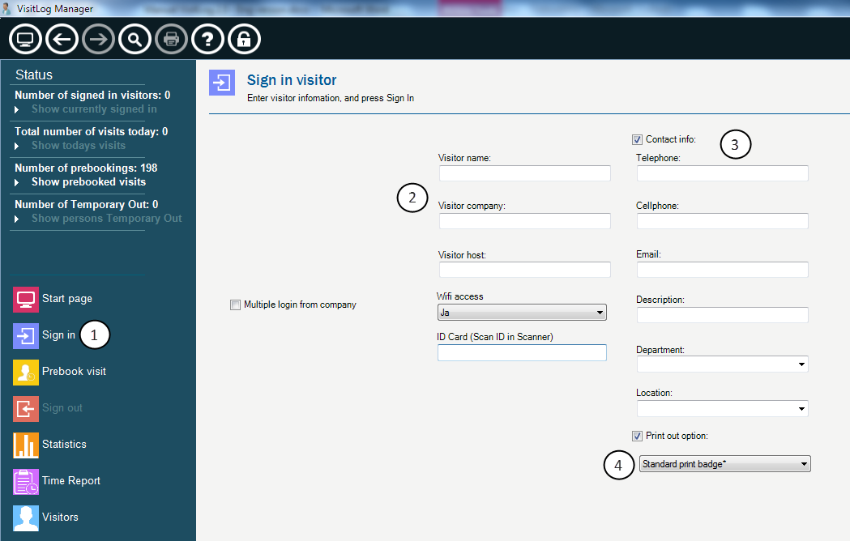
- Click link to login visitor.
- Write visitor name, company and host.
- Here you can give more details to user. This will be visible next time visitor login.
- If you have more than one option/template and printer. You can choose to print at different printers with different templates here.

Prebook visitor
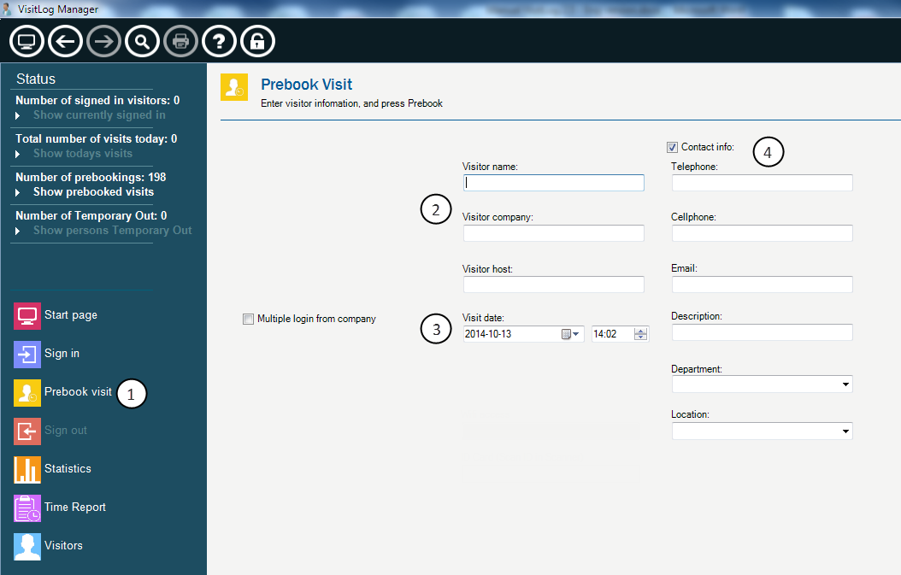
- Prebook visitor option in left panel.
- Add name, company and host
- Set date for visit.
- Add extra details if any.

Check out visitor
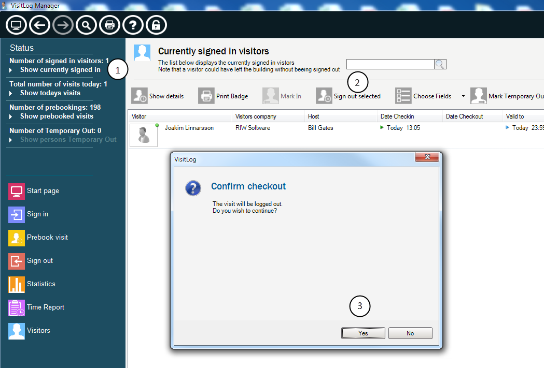
- Select Currently signed in users.
- Click ”Sign out selected”
- Click yes

Check out with barcode scanner
Barcode scanner is connected to pc with USB. When badgre barcode is scanned, user is either checked in or checked out.

Search
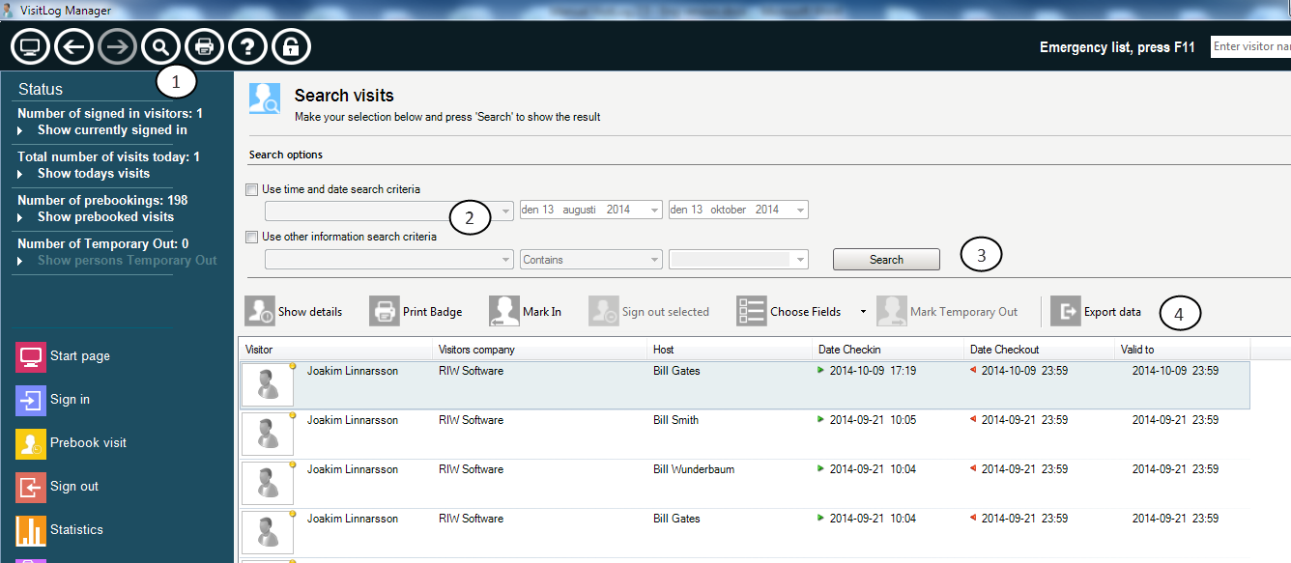
- Click magnafying glass for Search options.
- Select filtering for search list
- Click Search button
- Possible to export data/list to excel or text file.

Choose columns for lists
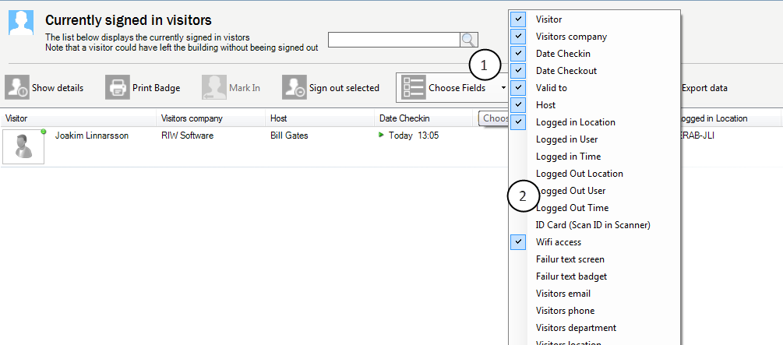
- In any list, please click ”Choose fields”
- Select any column that you will see in list.

Statistics
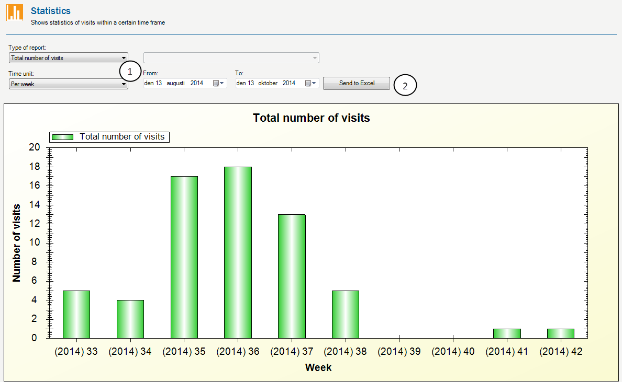
- Make selection in these drop downs and see result in chart below.
- Possible to export chart values to excel.

Time report
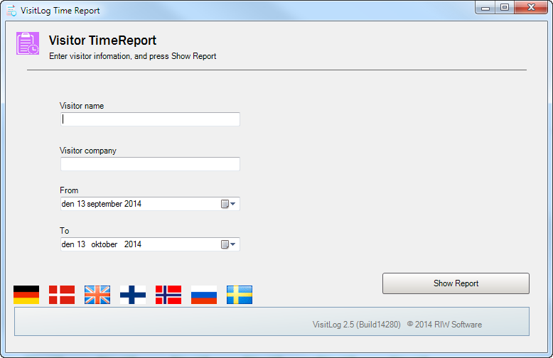
- Fill whole value or part of value to search fields.
- Give From and To date filter.
- Click “Show Report” button.

Users and rolesoverview
User and rolls will help to limit what users can do in the system. Rightscan be limited for:
- What users can do: What functions/commands and more
- What user can see: What departments/locations that user should be able to manage

Users and commands
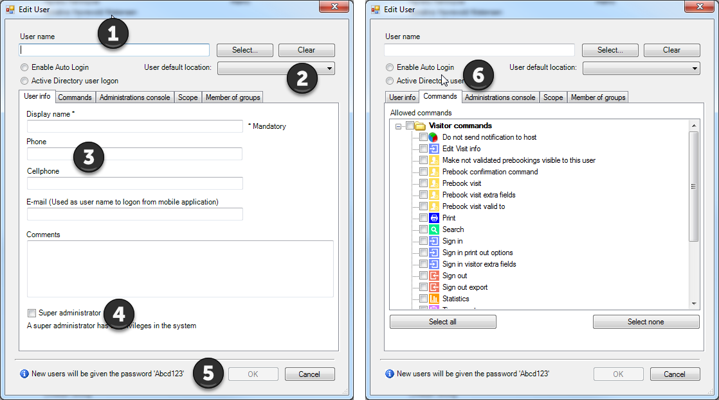
- Name at user (Login name) if same name is used as for windows logon, autologon function can be used.
- Set users standard/default location. What is show when open visitlog
- More info. Mail is used for mobile application logon.
- Superuser option is used to get all rights and commands in the system.
- Default password with new users are: Abcd123
- The tab ”Commands” is used to set what to do in the system.

Users – Rights and location
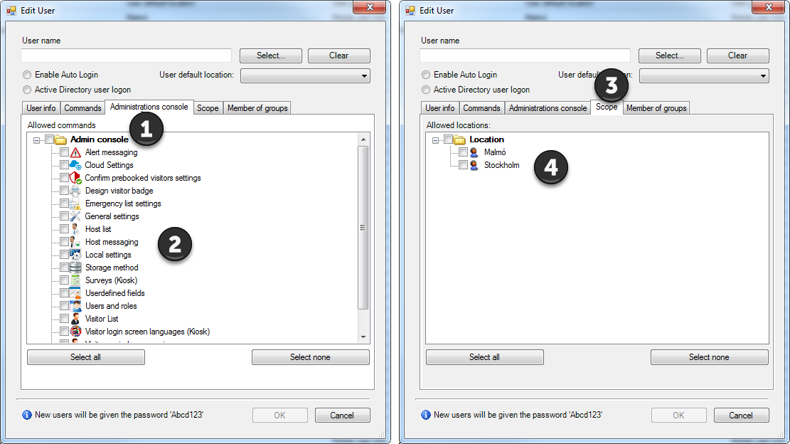
- Tab administration console can set what in administration that user can see and use.
- Here is the things to check for user to be able to use
- Scoop tab is to be used when multiple locations is used.
- Here you can set to see one location or many.

User – Group settings
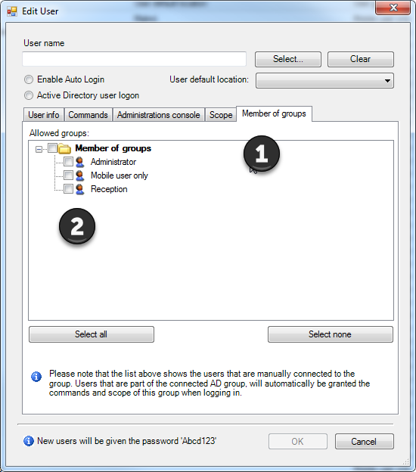
- Tab Members of Group gives what group user belong to (If group function is used)
- If there is many users and different rights, it can be easier to set a group and add new users to that group and user got rights and scoop as the group.

Presentation screen
Module for presentation screen is possible to add. It will show todays visits in a screen. Module will demand for Web server to be used as page for list.
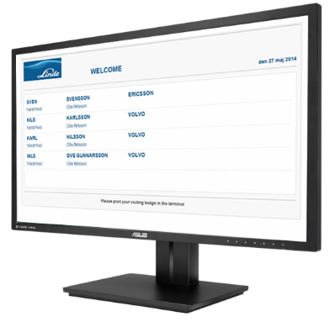

Short Cut Commands
Sign in Visitor Ctrl + R
Prebook Visitor Ctrl + F
Start Search Ctrl + S
Show emergency list Ctrl + Q
Show prebooked users Ctrl + B

